Research Login/Registration Forms

1. 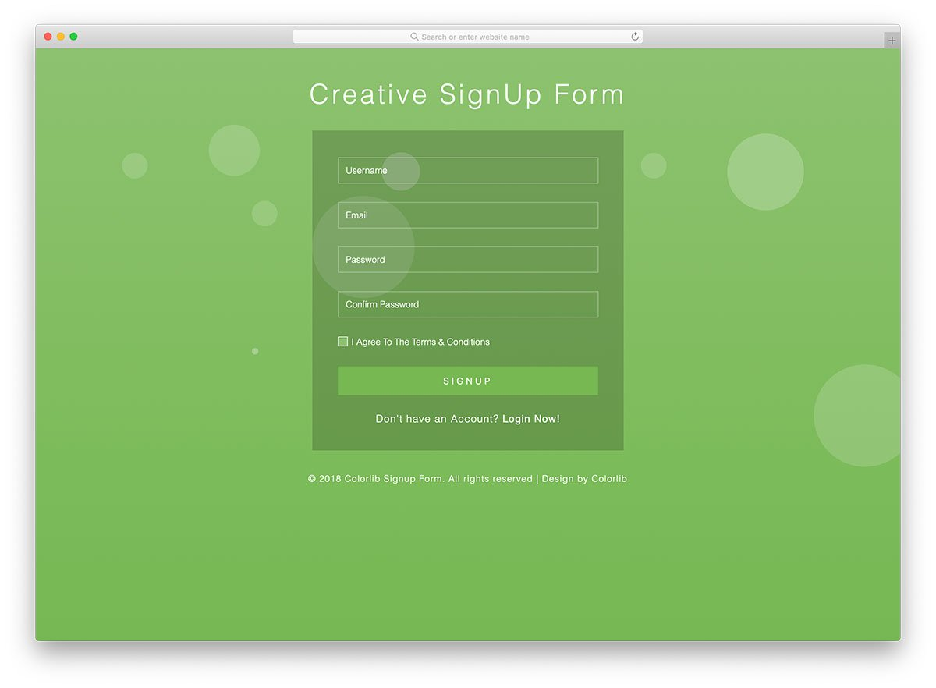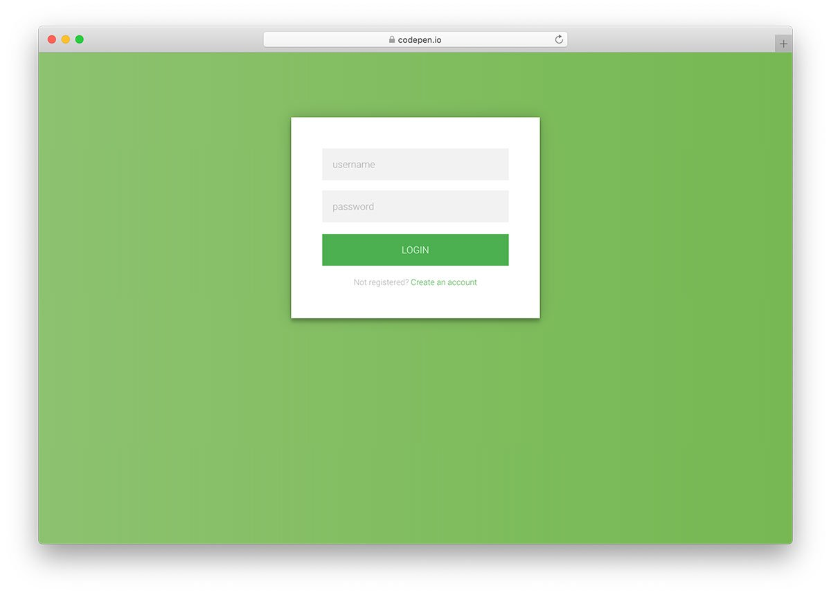

I really like this login registration form because it is very simple to develop and very easy for users to input their information. However, I dislike the font color because it might be hard for people to see what they are typing.

1. 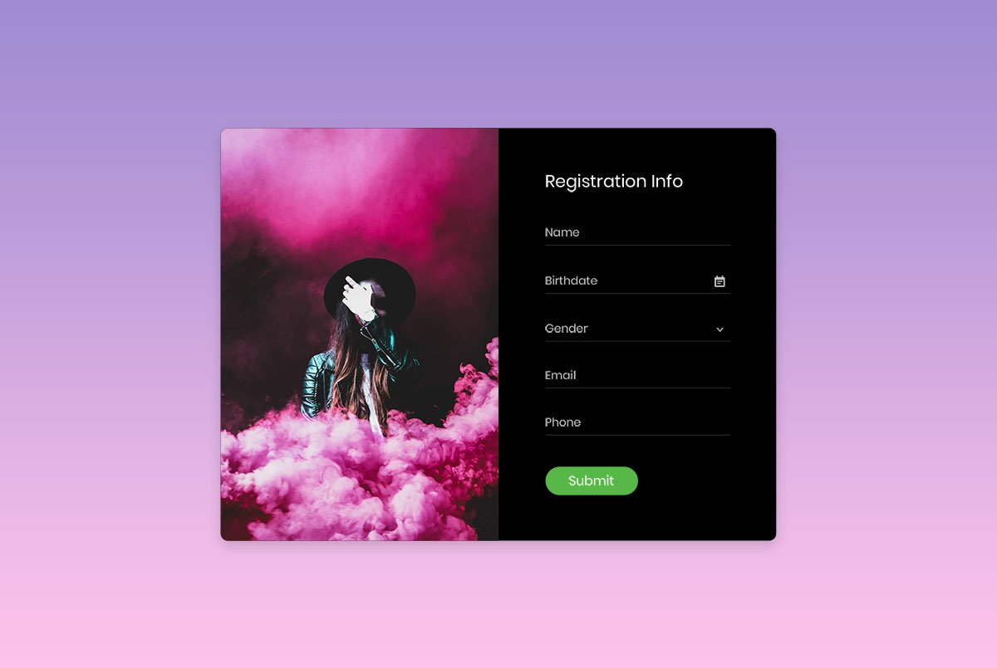

I really like this design because it is very modern. Not only that, the picture captures the attention of the audience and is very easy to register because there is very little things to input.

1. 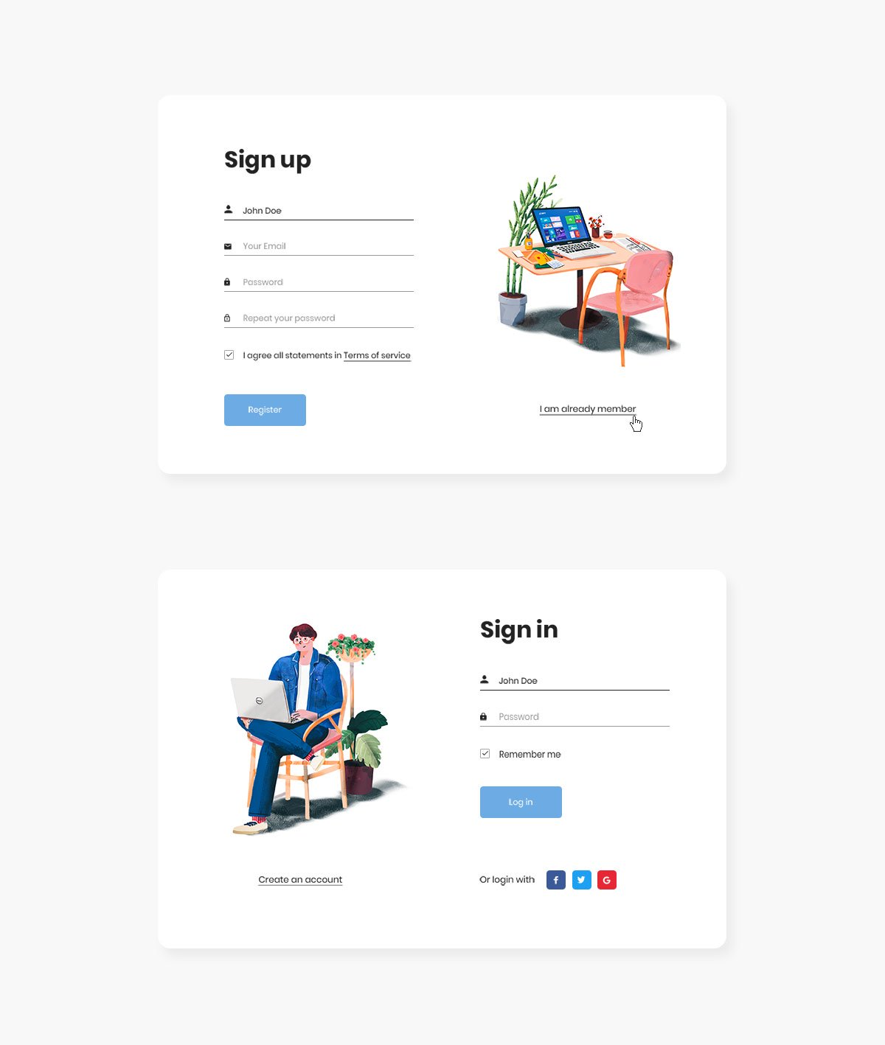

I really like this design because it is very simple and does not disrupt the main purpose of the form, which is allow users to register and login into their accounts. I do not have any dislikes for this design. I quite like it.